**Comparison Operators**

== Equal to

!= Not equal to

< Less than

> Greater than

<= Less than or equal to

>= Greater than or equal to

**Boolean operators**

**and** #evaluates to true if both statements are true, if not it's false.

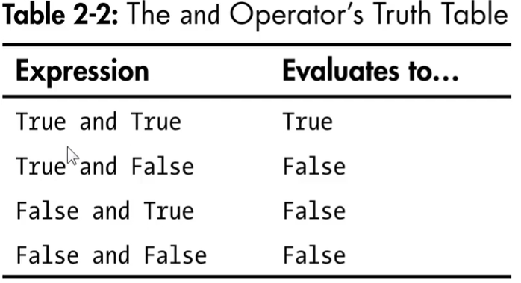

**or** #evaluates to true if either or both are true. only false if both are false.

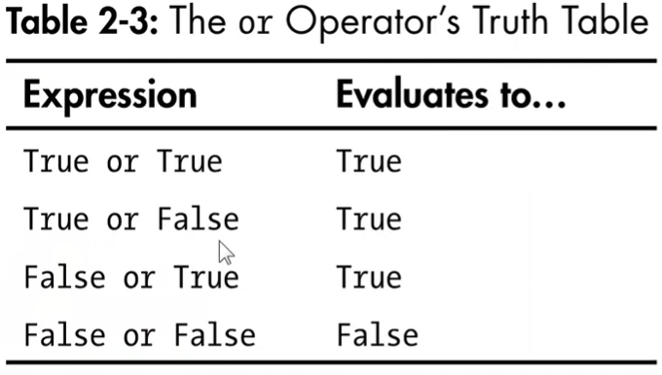

**not** #evaluate to the opposite boolean value

